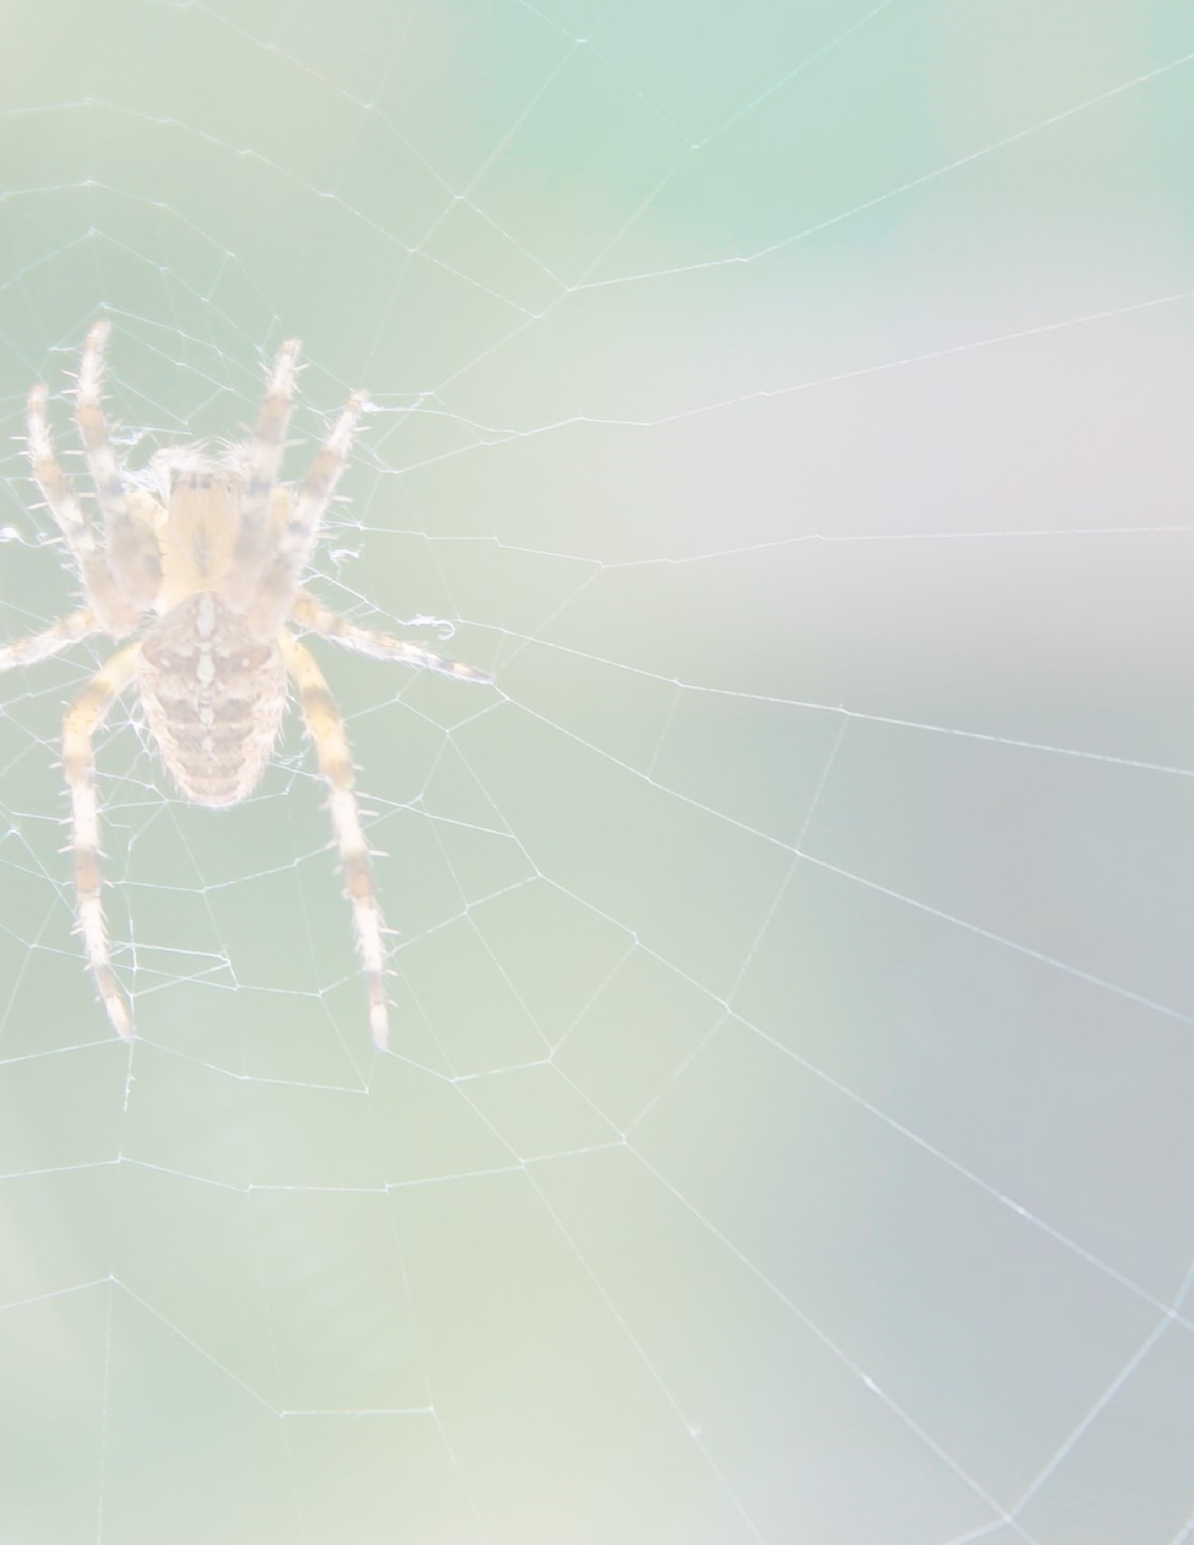
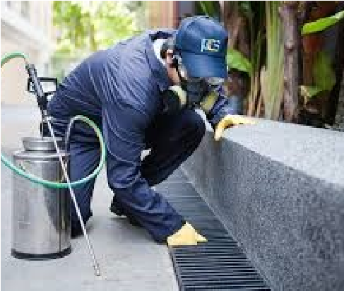
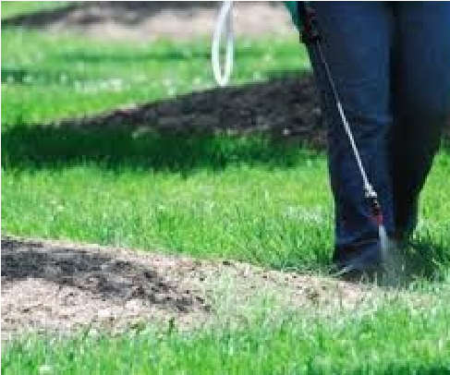
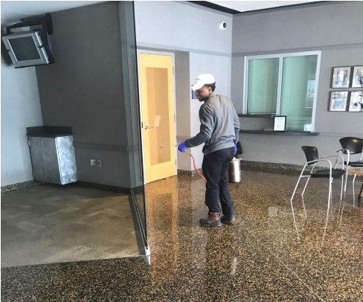
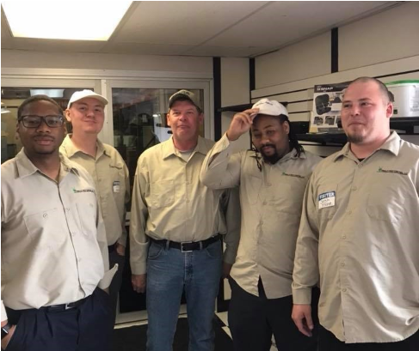
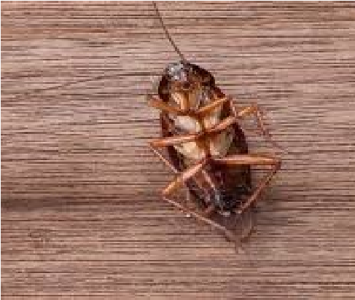
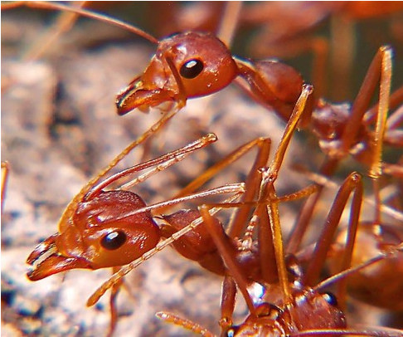
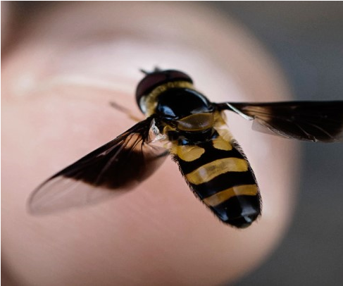
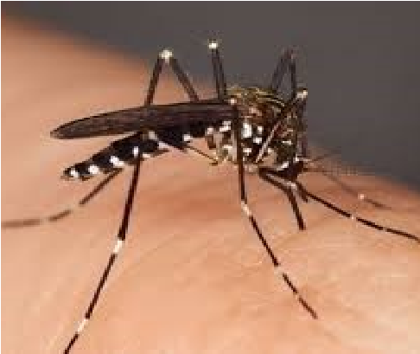
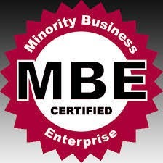
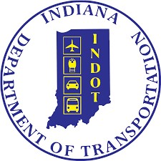
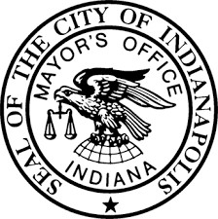
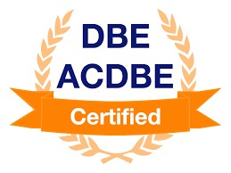
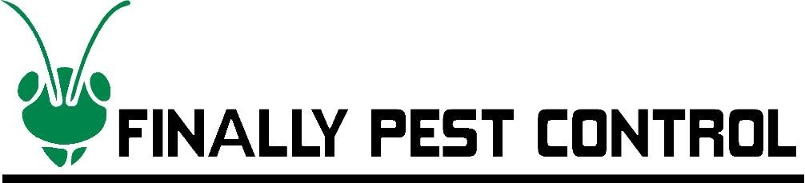
We offer both monthly maintenance and
one
-
time emergency services to meet the
individual needs of our customers.

Maintenance Services

Finally Pest Control, LLC
is a DBE Certified, company, based in the state
of Indiana. We take pride in both our work, and our relationship with our loyal customers.
Our number 1 priority is YOU the customer. We help our clients to identify their best pest
control management plan while providing Eco
-
friendly solutions that are safe within your
business environment.

Cockroaches, Rodents, Bees, Wasps, Termites,
Ants, Beetles, Bird
-
control, Bed Bugs, Ticks &
Fleas, Fruit Flies, Horse Flies, and many more!

Pests we Target

How we are Different

◻

We offer online appointment scheduling. 24/7

◻

We currently have a
Quantity Purchase Agreement
to
service the entire State of Indiana State Government,
Indiana State Police, Department of Natural Resources
and city entities for pest control. To view agreement
click here:
www.in.gov/idoa/proc/QPA/17217.pd
f

◻

We offer regular pest control, termites soil treatment,
and bird barriers.

Clients we Service Statewide

→

Department of Child Services for Indiana

→

Indiana State Hospital (FSSA)

→

South Bend Housing Authority

→

Indiana Department of Transportation

→

Department of Natural Resources

→

Indiana State Police

Our Company Data

DUNS: #
055170363

Cage Code:
RW
81
7

NAICS Code:
561710

CERTIFICATIONS:

E. 116th Street #
10
9783

Fishers, Indiana 46037

Office Phone: 317
-
747
-
1742

E
-
Mail:
support@finallypestcontrol.com

Website:
www.finallypestcontrol.ne
t

